Advanced Games Programming
Tutorial 10 - Loading and Drawing Objects using a Model Class

Introduction

So far you have been drawing cubes and other simple objects that you have directly created using vertex arrays in your code. In this tutorial you will take a look at one way to load and store 3D objects created externally in an object creation tool (such as 3DS Max), and how to manipulate and draw that model onscreen.

Using Object Files

The objects that you have been using so far have been very simple ones, with only a few vertices that are predefined in code by directly initialising the vertex arrays. Whilst it would be possible to create more complex objects using this method, it would soon become clear that this way of representing objects is not particularly easy to manage, especially if you wanted to alter the object to change its appearance. A much better way of creating and changing objects is to do so using an object creation tool of some kind, then saving that object to a file. This file can then be loaded by the application in order to manipulate and to draw the object.

Loading Object files

There are a very large number of different object file types and potential ways of storing the object data using Direct3D. Because of this Direct3D does not contain any functionality for loading objects from a file, leaving this to the developer so that the loading can be done correctly for the specific data representation of objects for any given application.

For this tutorial you will be using Wavefront .OBJ files to store your model data. The main reason for this is because the data is stored as a text file rather than a binary format, which means that you can open the file up in a text editor to inspect the object data easily to help understand how the object is represented.

Creating an object loader is quite an involved task, so I have created a basic .OBJ file loader, in the objfilemodel class, which you can find on myCourse as .cpp and .h files. This file loader is quite basic in that it only deals with object position, texture coordinates and normals, it ignores other features that .OBJ files support. It also only deals with triangles, so objects that use quads or other shapes will not be loaded correctly.

.OBJ File Structure

Each line of a .OBJ file represents a specific set of data, such as position, texture coordinate, normal or face(triangle). The objfilemodel class recognises these four different types of data and ignores everything else. A very simple model of a single triangle could be represented as follows:
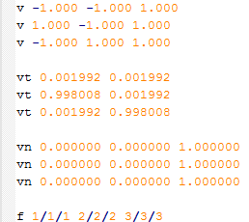

The first three lines starting with 'v' represent vertex positions, the three values on the line represent the x, y and z values. The next three lines that start with 'vt' represent texture coordinates, with two values representing u and v. The 'vn' lines represent vertex normals, and again have three x, y and z values. The final type, 'f' represents faces, or in this case triangles as there are three groups, one group is 1/1/1 for instance. Each group represents a single vertex, and each element of the group separated by forward slashes is an index into the previously defined position, texture coordinate and normal values (in that order). So the first group says that the first vertex of the face consists of the first position, the first texture coordinate and the first normal, i.e.:

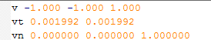

and so on for the other groups for the other two vertices. This is a very simple object with just a single triangle, take a look at more complex objects to see how the indexing works in a more realistic example.

A .OBJ file doesn't have to provide texture coordinates or normals, so the face type will look like the following in various combinations:

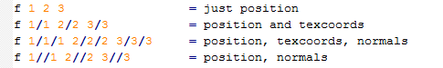

Creating Object Files

Because the provided object loader doesn't support all types of .OBJ files it is important that you create your objects in the right way, and also set the export setting correctly from whichever modelling application you are using. First of all the provided loader code does not cope with objects with more than one texture applied, nor does it deal with any materials so you should restrict yourself to a single texture and no materials for the objects you create (handling extra textures and materials is an Advanced Exercises if you want that functionality). You also need to ensure that various options are set, such as options that export texture coordinates and vertex normals, and that the file is exported using triangles. You can leave the material exporting turned on (you need it on if you were going to rewrite the loading code to support materials for instance), but it will be ignored by the provided loader. You might also need to set any axis flipping options, and/or rotate your model in order for the 'front' of the model to face the correct way when loaded, this will depend on how you have created your models. This step might be needed as the modelling tool may have the xyz axes in a different orientation to your Direct3D application, where the front of an object will be facing down the positive z axis by default.

When exporting from 3DS Max for instance you will see a dialog box similar to this:

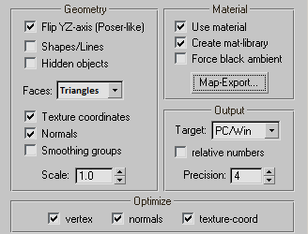

The above settings are a good start, but some experimentation may be required before your model is correctly exported. Other tools will have similar settings.

Using the objfilemodel Class

The objfilemodel class files can be downloaded from the zip file on myCourse. Copy the objfilemodel.cpp and objfilemodel.h files to the project folder of any project that needs to load models. Add the .cpp and .h files to your project as usual in order to use the class.

Loading and Drawing an Object

In order to load an object in from a .OBJ file you need to first include the objfilemodel.h header file, then declare an ObjFileModel pointer and create a new instance. Here is a sample that would create a standalone object:

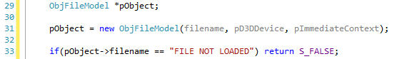

The constructor takes a filename, the D3D device pointer and context pointer. The constructor loads the object data from the file and parses it to create a D3D vertex buffer that represents the object. If the file cannot be loaded for any reason the function will output an error message to the debug output, and sets the filename attribute of the model to "FILE NOT LOADED", which should be checked after the constructor is called, as shown above. The file load code also checks to see if the data in the .OBJ file being loaded is in the correct format, and if not will output a message to the debugger output window explaining the problem and what line in the .OBJ file it is on. If your model is not displaying correctly you should check the output to see if any of the data is not in the correct format.

Drawing the object is done simply by calling:

the ObjFileModel Draw() method sets the object's vertex buffer as active and calls the vertex buffer draw method. This will render the vertices with whatever shaders, textures, and constant buffer data that are currently set.

When the model is no longer needed, call the destructor to delete it:

Exercise 01 - Creating a Model Class

Now you are able to load and display objects from file it is time to create a Model class that encapsulates everything needed to load, manipulate and draw objects. The Model class will load and store an object, which will then be assigned its own shaders, input layout and constant buffer. It will have attributes that describe and manipulate its position, rotation and scale, and a method to draw the object onscreen using all these attributes.

- Copy the objfilemodel.cpp and objfilemodel.h files from the zip file on myCourse to your project folder, and add them to your project.
- Create Model.cpp and Model.h files in your project.
- Use #pragma once in the header file to ensure the header isn't included twice.
- Include objfilemodel.h in Model.h.
- Include Model.h in Model.cpp and main.cpp.
- Create a Model class in the Model.cpp and Model.h files
- The Model class should have the following private attributes:
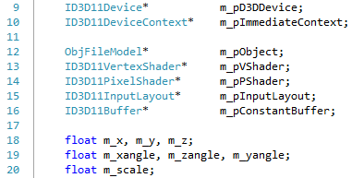
- The Model Constructor should take two parameters, ID3D11Device* and ID3D11DeviceContext*, and should store the passed in pointers in the relevant attributes. All of the floating point attributes should be set to 0.0f, except for m_scale, which should be set to 1.0f.
- Add a model_shaders.hlsl file to your project, and add the following basic shader code to it:
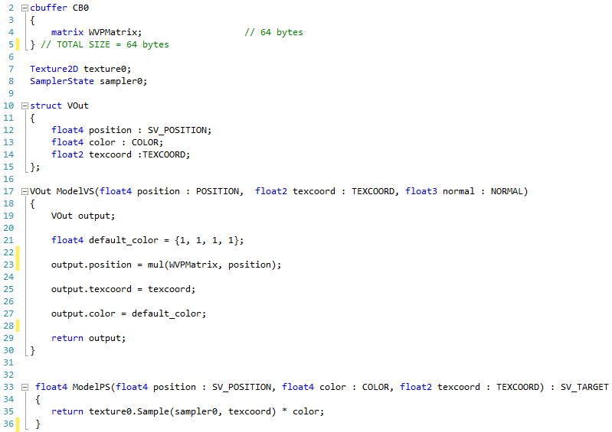
- Add a public LoadObjModel() method that :
  - Takes a single char* parameter representing a filename, and returns an int. This function should first create a new ObjFileModel as shown in the tutorial (using the m_pObject pointer member attribute instead), with the filename passed in and the previously stored device and context pointers. Don't forget to check that it has been successfully loaded.
  - Using your existing code as reference, compile the shaders "ModelVS" and "ModelPS" from the model_shaders.hlsl file and use the compilations to create shaders in the m_pVShader and m_pPshader pointers respectively.
  - Create an input layout that has POSITION, TEXCOORD, and NORMAL attributes in that order, and store in m_pInputLayout.
  - The model vertex shader currently only requires the world-view-project matrix to be uploaded to the constant buffer, so create a constant buffer of size 64 bytes in m_pConstantBuffer.
- Add the following constant buffer struct just after the #include directives of Model.cpp:
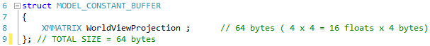
- Create a public Draw() method that takes 2 XMMATRIX pointers called view and projection. Again referencing your existing code:
  - Declare an XMMATRIX called world, and create a transformation using m_rotation, m_scale, m_x, m_y, m_z attributes of the Model. The order is important as usual, do rotation, then scale then translation. When doing scale you can pass the m_scale attribute to all three parameters of the scale function to get a uniform scale in all direction:
  - Create a new constant buffer structure, and set its WorldViewProjection matrix as follows:
The view and projection matrices are passed in as pointers, so the (*view) terminology dereferences the pointer in the brackets first, before doing the matrix multiply with *.
  - Set the Model constant buffer to be the active one using VSSetConstantBuffer() and update the constant buffer with the WorldViewProjection matrix using UpdateSubresource().
  - Set the Model's vertex shader, pixel shader and input layout as the active ones.
  - Call m_pObject's Draw() method to draw the object.
- The Model destructor should delete m_pObject, and release the shaders, the input layout and the constant buffer.
- Add public methods that sets each of the position, rotation and scale attributes, e.g. SetXPos(float num).
- Add public methods that gets each of the position, rotation and scale attributes, e.g. float x = GetXPos().
- Add public methods that increments (or decrements with a negative input) each of the position, rotation and scale attributes, e.g. IncXPos(1.5f).
- In main.cpp, add a global Model* variable.
- At the start of the InitialiseGraphics() function add code that creates a new Model, passing in the device and context pointers, then loads an object into that model using LoadObjModel(). You can use your own .OBJ model, or the sphere.obj and cube.obj models provided in the zip file on myCourse. Put your models in the assets folder.
- In RenderFrame():
  - Comment out any existing object drawing code. Ensure you keep any code that clears the rendertarget and depth buffers, creates the view and projection matrices, and sets the samplers and textures.
  - Use the Model Set and/or Increment methods to move, scale and rotate the object using the keyboard and/or mouse.
  - Call the Model Draw() method, passing in the addresses of the view and projection matrices. If you can't see the model, ensure that it is not scaled too large or small, and that the camera is not inside the object.
- Delete the model in the ShutdownD3D() function before releasing the D3D resources.

